DOCUMENT 3
GROUP & ROLE HIERARCHY FRAMEWORK

Organizational Structure in ServiceNow
In ServiceNow, the 'Organizational Structure' is the primary foundation for efficient ticket routing. At ABC Corporation, support agents are organized into 'Groups' based on their technical expertise. This structure is essential for the automation engine to accurately identify the target team. Without this hierarchy, tickets would accumulate in a single queue, leading to operational confusion and delays.
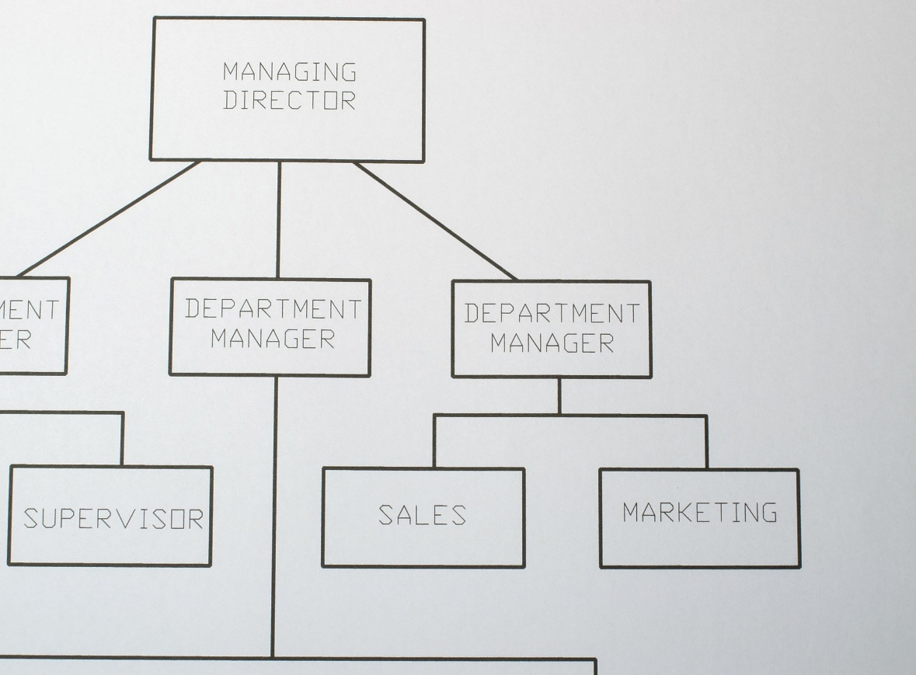
Getty Images

System Security - Groups Module Introduction
To manage groups within ServiceNow:
- Filter Navigator: Type "Groups" in the search bar.
- Module Selection: Under the 'System Security' application, select the 'Groups' module.
- Interface: This interface allows for the creation of new teams and the management of group leaders. This module is critical for maintaining data security and controlling ticket visibility.
Group Creation - 'Certificates' Group (Part 1)
Steps to create the support group:
- Name: Certificates
- Manager: Katherine Pierce (Select her profile from the user reference list).
- Parent: (Leave blank as this is a top-level functional group).
- Active: Ensure this checkbox is selected to enable the group for routing.
Group Creation - 'Certificates' Group (Part 2)
Primary responsibilities of this group:
- Handling tickets related to SSL Certificates and Digital Signatures.
- Participating in internal security audits.
- Katherine Pierce will lead specialized training sessions for group members to maintain service standards.

Group Creation - 'Platform' Group (Part 1)
Steps to create the technical support group:
- Name: Platform
- Manager: Manne Niranjan (Select his profile from the user reference list).
- Description: Dedicated to platform-related issues such as Login errors, 404 incidents, and system downtime management.
Group Creation - 'Platform' Group (Part 2)
Primary responsibilities of this group:
- Monitoring server maintenance and application performance metrics.
- Resolving high-priority issues such as 'Unable to login' incidents promptly.
- Escalating identified platform bugs to the core development team for permanent fixes.
Group Email & Description Configuration
- Group Email: certificates-support@abccorp.com and platform-support@abccorp.com.
- Purpose: When a ticket is assigned to a group, an automated notification is sent to the group email to alert all members.
- Description: Clearly defining each group's scope helps prevent manual misassignment by agents.

Role Definition - 'Certification_role' Creation
Roles define the functional permissions within the system:
- Module: Navigate to System Security >> Roles.
- New Role: Name it Certification_role.
- Description: This role grants permission to view and update certificate-related operational records.
- Elevated Privilege: Not required for this functional role.
Role Definition - 'Platform_role' Creation
- New Role: Name it Platform_role.
- Description: This role provides access to platform maintenance logs and user login issue tables.
- Access: Only agents assigned this role can modify platform-specific records in the 'Operations related' table.
Assigning Roles to Groups (Inheritance)
ServiceNow 'Best Practice' dictates that roles should be assigned to groups rather than individual users:
- Inheritance: By assigning the Certification_role to the 'Certificates' group, all current and future members automatically inherit the role's permissions.
- Benefit: When a new agent joins the team, simply adding them to the group grants them all necessary access rights instantly.

Adding Users to Groups (Membership Management)
Linking users to their respective teams:
- Group Record: Open the 'Certificates' group record.
- Related List: Navigate to the 'Group Members' tab at the bottom.
- Edit: Click 'Edit' and add Katherine Pierce.
- Repeat: Follow the same steps for the 'Platform' group to add Manne Niranjan.
Role-Based Access Control (RBAC) Summary
- RBAC: Through this framework, 'Certificates' team agents are restricted from modifying 'Platform' team data. This ensures data integrity and security.
- Conclusion: Establishing a correct User -> Group -> Role hierarchy is the mandatory foundation (Authority) for successful automation.

